Pupil premium strategy statement – St Josephs Infants school 1st April – 31 March 2026

This statement details our school’s use of pupil premium funding to help improve the attainment of our disadvantaged pupils.
It outlines our pupil premium strategy, how we intend to spend the funding in this academic year and the outcomes for disadvantaged pupils last academic year.

School overview
Detail | Data
Number of pupils in school | 125
Proportion (%) of pupil premium eligible pupils | 29 pupils
Academic year/years that our current pupil premium strategy plan covers (3-year plans are recommended – you must still publish an updated statement each academic year) | 2025-2028
Date this statement was published | Oct 2025
Date on which it will be reviewed | Sep 2026
Statement authorised by | L Hardy
Pupil premium lead | N Metcalfe
Governor / Trustee lead | Stephen Hague

Funding overview
Detail | Amount
Pupil premium funding allocation this academic year | £42,720
Pupil premium funding carried forward from previous years (enter £0 if not applicable) | £0
Total budget for this academic year  If your school is an academy in a trust that pools this funding, state the amount available to your school this academic year | £42,720

Part A: Pupil premium strategy plan

Statement of intent
St Josephs Infant school is a culturally diverse school with a hardworking, enthusiastic, and dedicated staff team. We have a New Senior Leadership Structure 2025 which encompasses an Executive and Head of school team and a school ethos of no excuses, the highest expectations, urgency, and children and staff at the heart of all we do.

We have 2 schools on 1 site with significant deprivation, EAL pupils, refugees and children who start school with very low-level language skills. We have 28 languages within the school 35.1% of our pupils speak English as an additional language. 47.4% Minority Ethnic backgrounds and 27% SEND pupils

We have a strong ethos of inclusion and crucially a compassionate approach towards engaging and supporting our children and parents. There is a collective understanding of the impact of disadvantage on pupils’ learning and the school and Trust are clear about our God given potential for all our pupils and they understand the part they play in addressing educational disadvantage.

Through leadership capacity, there is focus on the quality of pupils’ learning experiences. Our leadership team play a significant role in evaluating progress through ongoing, and supportive monitoring through quality assurance. Collaborative team planning teaching, and modelling provides on the spot coaching, training, and immediate feedback to develop practice.

Challenges
This details the key challenges to achievement that we have identified among our disadvantaged pupils.
Challenge number | Detail of challenge
1 | Assessments, observations and discussions with staff/pupils/families have identified that many of our educationally disadvantaged pupils experience several challenges which potentially impact on their learning. They are at risk of underachievement because of the impact of socio-economic (and other) disadvantages on their lives over time and we see it as our job to focus on the main thing – ensuring highly effective early intervention and high-quality classroom practice for all – so that every child can experience success in the classroom.  2024/2025 data continues to show a gap between PP pupils and NPP in reading, writing and maths at end of KS1 at 16%  2024 2025 data continues to show a gap between PP pupils and NPP in phonics for Year 1 by 35%
2 | We have identified an increase in social and emotional issues for many pupils. These challenges particularly affect disadvantaged pupils, including their attainment and attainment.  Teacher referrals for support have markedly increased since the pandemic and subsequent cost of living crisis. These pupils are again at risk of underachievement because of the socio-economic (and other) disadvantages on their lives
3 | Disadvantaged pupils experience several challenges which potentially impact on their learning, wider school life and their experiences beyond the school gate. These pupils may be at greater risk of poor attendance because of the impact of socio-economic (and other) disadvantages on their lives over time.  Our overall whole school attendance in  2023/24 91.7% 2024/2025 91.4%  Attendance for Pupil Premium 2023/24 89.4 % 2024/2025 90.3%
4 | 2024/2025 91.4% Attendance for all our pupils still needs to improve which is why whole school attendance and persistence absenteeism remains a focus of this current plan - we know pupils experiencing success in the classroom is key to improving their life chances
5 | Limited access to wider opportunities and enrichment experiences  Many of our disadvantaged pupils face barriers to accessing wider opportunities beyond the classroom, including enrichment activities, cultural experiences, and extracurricular learning. These limitations are often due to socio-economic factors such as financial constraints, or limited awareness of available opportunities. This impacts pupils’ development of cultural capital, social skills, confidence, and aspirations. Without targeted support, these pupils are at risk of missing out on experiences that contribute to their personal development, wellbeing, and long-term educational outcomes.

Intended outcomes
This explains the outcomes we are aiming for by the end of our current strategy plan, and how we will measure whether they have been achieved.
Intended outcome | Success criteria
Improved reading and writing attainment for disadvantaged pupils at the end of KS1 | Reading and writing outcomes in 2026/27 will be improved by 6%
Improved Phonics and reading attainment for disadvantaged pupils at the end of KS1 — aligned with St Josephs strategic priorities and measurable indicators: | Phonics outcomes in 2025/27 are consistently in line with Trust averages and agreed internal targets.  Phonics outcomes for disadvantaged pupils consistently in line with 2026/27.  Phonics scores for disadvantaged pupils show sustained improvement.  Internal assessment data (e.g. termly tracking, book scrutiny, formative assessments) shows steady progress across all year groups, with disadvantaged pupils meeting or exceeding expected progress benchmarks.
To achieve and sustain improved attendance for all pupils particularly our disadvantaged pupils | Overall attendance for all pupils reaches at least 95% by the end of the strategy period (2025/27), meeting the school’s internal target.  Attendance gap between disadvantaged pupils and their peers is narrowed in line with national with both groups achieving comparable attendance rates.  Persistent absenteeism (defined as attendance below 90%) is reduced to below 10% across the school.  peers, indicating equitable engagement.  Improved parental engagement and reduction in attendance-related barriers, evidenced through:  Increased participation in attendance support programmes.  Positive feedback from families via surveys and consultations.
To achieve and sustain improved wellbeing for all pupils in our school, particularly our disadvantaged pupils. | Sustained high levels of wellbeing from 2025/27 demonstrated by:  - Qualitative data from student voice, student and parent surveys and teacher observations  A significant increase in participation in enrichment activities, particularly among disadvantaged pupils  Improved Pupil Voice and Engagement  Pupil surveys and focus groups show a year-on-year increase in reported wellbeing, sense of belonging, and enjoyment of school.  Disadvantaged pupils report feeling safe, supported, and included at rates comparable to their peers.  Access to Support Services  All pupils identified as needing emotional or mental health support receive timely intervention (e.g. ELSA, counselling, nurture provision).  Feedback from staff and families confirms the effectiveness and accessibility of support services.  Staff Confidence and Capacity  Staff surveys show increased confidence in supporting pupil wellbeing and trauma-informed practice.  CPD records demonstrate sustained engagement with wellbeing-focused training across all staff roles.
To ensure all pupils, particularly disadvantaged pupils, have access to wider opportunities and enrichment experiences. | Increased Participation in Enrichment Activities  At least 65% of disadvantaged pupils participate in one or more enrichment activities (e.g. clubs, trips, enrichment activities) by 2027.  Participation data shows a narrowing gap between disadvantaged and non-disadvantaged pupils.  Equitable Access to Opportunities  Financial, logistical, and pastoral barriers to participation are identified and addressed through targeted support (e.g. subsidies, transport, parental engagement).  All enrichment activities are designed with inclusivity and accessibility in mind.  Positive Impact on Engagement and Aspirations  Pupil voice indicates increased confidence, motivation, and aspiration linked to enrichment experiences.  Staff observations and pupil reflections show improved engagement and self-esteem among disadvantaged pupils.  Curriculum Integration and Cultural Capital  Enrichment experiences are embedded within the curriculum to enhance cultural capital and deepen learning.  Evidence from planning and pupil work shows meaningful links between enrichment and academic outcomes.  Family and Community Involvement  Increased family participation in enrichment-related events (e.g. performances, exhibitions, celebration assemblies).  Stronger partnerships with local organisations and providers to broaden the range of opportunities available.

Activity in this academic year
This details how we intend to spend our pupil premium funding this academic year to address the challenges listed above.

Teaching (for example, CPD, recruitment and retention)
Budgeted cost: £ 4095
Activity | Evidence that supports this approach | Challenge number(s) addressed
- Overarching all strategies/activities:  Provide opportunities for internal skills sharing/modelling/ coaching/collaborative planning class teachers. | Effective whole school positive culture and implementation, focused on ensuring consistently highly effective classroom practice, including monitoring and evaluation by Trust advisor is key to the success of this strategy.  https://evidencebased.education/great-teaching-toolkit-cpd/ | 1
In reading, continue to develop teachers’ subject knowledge and modelling so that all teachers can effectively support the development of  children’s fluency and comprehension skills  High quality training, support and QA for teachers focused on phonics priorities:  - Continue to enhance our language rich learning environments  - Additional phonics sessions targeted at educationally disadvantaged pupils who require further phonics support (1:1 and group sessions)  - Reading leaders/Assistant head provide weekly coaching and training for staff at all levels Additional reading sessions targeted at educationally disadvantaged pupils who require further support (1:1 and group sessions)  - Coaching and Mentoring across the Trust school to school support.  - Run weekly after school boosters targeted at educationally disadvantaged pupils in reading through story time. | Phonics approaches have a strong evidence base indicating a positive impact on pupils, particularly from disadvantaged backgrounds. Targeted phonics interventions have been shown to be more effective when delivered as regular sessions over a period up to 12 weeks:  https://educationendowmentfoundation.org.uk/education-evidence/teaching-learningtoolkit/phonics  Evidence consistently shows the positive impact that targeted academic support can have, including for those pupils who are not making good progress across the spectrum of achievement.  https://educationendowmentfoundation.org.uk/support-for-schools/school-planning-support/2targeted-academic-support | 1
- In writing, continue to develop teachers’ subject knowledge and modelling so that all teachers can effectively support the development of high-quality sentence structure  - High quality training, support, QA and skills sharing for teachers focused on priorities:  - Teacher Talk - the teacher modelling their own thinking while modelling writing  - Fund subject leader and teacher release time to access English Hub training/ resources and CPD.  - Fund leadership time for 1 staff member to attend and lead whole school training an innovative, year-long Assessment for Learning (AfL) project: 'Feedback that Fuels Learning' | There is some evidence to suggest that disadvantaged pupils are less likely to use metacognitive and self-regulatory strategies without being explicitly taught these strategies  There are positive impacts from a wide range of feedback approaches – including when feedback is delivered by technology or peers. Impacts are highest when feedback is delivered by teachers. It is particularly important to provide feedback when work is correct, rather than just using it to identify errors.  Embedding formative assessment explicitly can be a key component of laying the foundations for effective feedback. The EEF has trialled ​‘Embedding Formative Assessment’ in English schools and found a positive impact, on average.  https://educationendowmentfoundation.org.uk/education-evidence/teaching-learning-toolkit/feedback | 1
- Invest in the NCETM Mastering Number programme for KS1 from September 25.  High quality training, support, QA and skills sharing for teachers focused on priorities:  - Continue to focus on one method per lesson and ensure consistently simple and effective maths lesson structure. | Mastery learning also appears to be particularly effective when pupils are given opportunities to work in groups or teams and take responsibility for supporting each other’s progress  https://educationendowmentfoundation.org.uk/education-evidence/teaching-learning-toolkit/mastery-learning | 1
- Mental Health lead training for 1 members of staff to support pupils self management of emotions. | Social and emotional learning (SEL) interventions seek to improve pupils’ decision-making skills, interaction with others and their self-management of emotions, rather than focusing directly on the academic or cognitive elements of learning. | 2

Targeted academic support (for example, tutoring, one-to-one support, structured interventions)
Budgeted cost: £ 8,800
Activity | Evidence that supports this approach | Challenge number(s) addressed
- Targeted intervention support for reading and writing in small groups  - Use of Clicker 8 | Research which focuses on teaching assistants who provide one to one or small group targeted interventions shows a stronger positive benefit of between four and six additional months on average. Often interventions are based on a clearly specified approach which teaching assistants have been trained to deliver.  https://educationendowmentfoundation.org.uk/education-evidence/teaching-learning-toolkit/teaching-assistant-interventions | 1-3
- Small group Tuition using ICT to target pupils’ specific needs. Use of Diagnostic assessments to support | The average impact of the small group tuition is four additional months’ progress, on average, over the course of a year.  Evidence shows that small group tuition is effective and, as a rule of thumb, the smaller the group the better. Some studies suggest that greater feedback from the teacher, more sustained the engagement in smaller groups, or work which is more closely matched to learners’ needs explains this impact. Once group size increases above six or seven there is a noticeable reduction in effective  Small group tuition | EEF | 1

Wider strategies (for example, related to attendance, behaviour, wellbeing)
Budgeted cost: £ 29,125
Activity | Evidence that supports this approach | Challenge number(s) addressed
Provide 1:1 and group counselling/ELSA sessions for vulnerable pupils led by skilled and experienced professionals both within school and externally | There is evidence to suggest that targeted school-based interventions have led to improvements in wellbeing and mental health, yielding reduced levels of school exclusion by 31% and improved pupil attainment (Banerjee et al., 2014)  - Social and emotional learning (SEL) interventions seek to improve pupils’ decision-making skills, interaction with others and their self-management of emotions, rather than focusing directly on the academic or cognitive elements of learning.  - Senior Mental Health lead support for attendance and wellbeing session daily  - SEL interventions might focus on the ways in which students work with (and alongside) their peers, teachers, family or community.  https://educationendowmentfoundation.org.uk/education-evidence/teaching-learning-toolkit/social-and-emotional-learning | 2
To provide enrichment activities to support the development of children’s Social and Emotional  Wellbeing such as Arts and Sports/Forest School | Children to have opportunities such as access to experiences to build on their cultural capital- trips, stem projects, author visits, projects across the Trust To ensure that the gap between disadvantage and non-disadvantaged pupils resources provision at home is diminished  https://educationendowmentfoundation.org.uk/education-evidence/teaching-learning-toolkit/arts-participation | 5

Total budgeted cost: £ 42,020

Part B: Review of the previous academic year

Outcomes for disadvantaged pupils
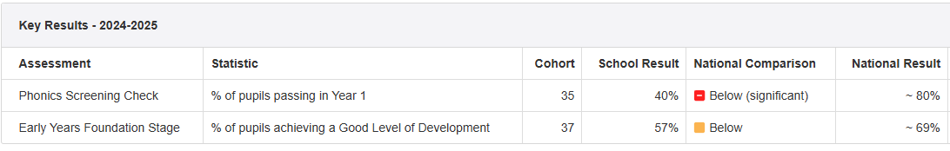
Disadvantaged outcomes for KS1 2024 - 2025
Year 2 2024 2025 non disadvantaged Year1 2024 2025 non disadvantaged
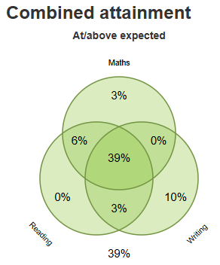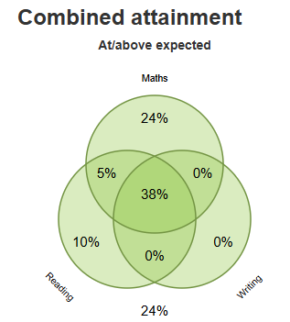

Year2 Disadvantaged 2024 2025 Year1 Disadvantaged 2024 2025
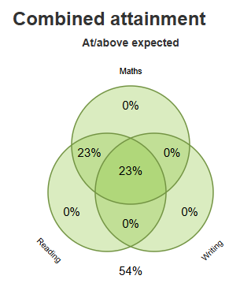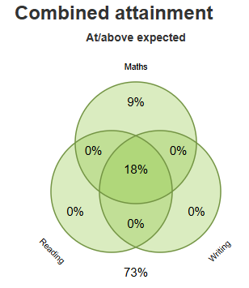

Externally provided programmes
Please include the names of any non-DfE programmes that you used your pupil premium to fund in the previous academic year.
Programme | Provider
White Rose Maths | White Rose Hub
Mastering Number | Maths Hub
Worthit | Worthit mental health training
Little wondl
Clicker 8 | Clicker

Service pupil premium funding (optional)
For schools that receive this funding, you may wish to provide the following information: How our service pupil premium allocation was spent last academic year
N/A
The impact of that spending on service pupil premium eligible pupils
N/A

Further information (optional)
Our strategy for all our educationally disadvantaged pupils is based on three key principles:
We focus on:
- The vital importance of an open and enthusiastic culture and positive relationships (staff, pupils, parents, governors, external partners and the wider community)
- The highest expectations of all staff and pupils and a clear and shared understanding of what constitutes high quality classroom practice through our use of words (highest expectations, urgency, flexibility, immediate intervention, challenge, support and high quality adult-child interactions)
- Leadership at all levels – a clear and shared ambition for and understanding of the learning needs of our disadvantaged pupils and collective responsibility for raising standards of teaching and learning and outcomes across the whole school community.

