
St Joseph’s Nursery, Infant & CE Junior
Schools
Orchard Street
Chichester
West Sussex
PO19 1DQ
Tel: 01243 783709
Email: office@stjosephscejunior.school office@stjosephsinfant.school
Website: www.stjosephscejunior.school www.stjosephsinfant.school

Executive Headteacher: Mrs Nicky Metcalfe BA Ed (Hons) NPQH. Head of School: Mr Gareth Lehmann BA Ed (Hons)
____________________________________________________________________
24th March 2026

Dear Parents and Guardians of KS1
We are delighted to share an exciting opportunity for all KS1 classes. Marsh Farm Dairy and Caroline’s Ice Cream, based at Chalder Farm in Sidlesham, have kindly invited us for a special visit to discover the fascinating world of farming and dairy production. During the visit, the children will enjoy a guided tour of the farm, meet the animals, discover how milk travels from farm to table and enjoy a day outdoors!
Owl Class will visit on Wednesday 15th April 2026
Wren Class will visit on Wednesday 22nd April 2026
Goldfinch Class will visit on Wednesday 29th April 2026

As the weather is currently very changeable, please ensure your child wears their school uniform along with suitable outdoor clothing, such as a waterproof coat and wellies, nearer the time we may request suncream and a hat! The children will be eating lunch during the trip, lunches will be provided but please can they bring their water bottle. There is space on-site where we will be able to leave all belongings, so the children will not need to carry their items while exploring the farm. To choose the packed lunch please complete the online form here:

School Trip Packed Lunch (2) – Fill in form
OR Scan the QR code:


Children will need to be dropped off at Chalder Farm at 10:00am and collected at 2:00pm. If you are able to offer lifts or require support with transport, please speak to us as soon as possible so that arrangements can be made. Directions can be found on the back of this letter.
We will also require parent helpers to make this trip possible. If you are able to join us, please speak to your child’s class teacher or email the school office. All parents /carers MUST sign the farm’s waiver form to be able to attend this trip (this has been handed out).
If you have any questions, please don’t hesitate to contact your class teacher.
Best Wishes, The KS1 Team
Getting to Chalder Farm: Chalder Farm, Sidlesham, Chichester, West Sussex PO20 7RN.
A = St Joseph’s Infant School
B = Chalder Farm

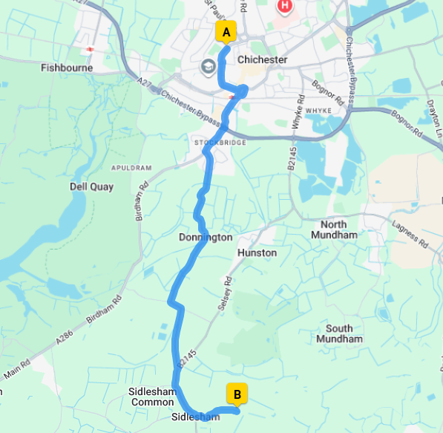
Leave St Joseph’s Infant School. Head southwest on Orchard St/A286 toward Orchard Grove. At Westgate Roundabout, take the 3rd exit onto Ave De Chartres/A286. At the roundabout, take the 1st exit and stay on Ave De Chartres/A286. Continue to follow A286. Turn right onto Basin Rd/A286. Slight right to stay on Basin Rd/A286. Turn left to stay on Basin Rd/A286. Continue to follow A286. At Stockbridge Roundabout, take the 2nd exit onto Stockbridge Rd/A286. At the roundabout, take the 1st exit onto B2201. Turn right onto B2145. Turn left onto Church Lane. Turn left onto Chalder Lane. Turn left, destination is on your left. Arrive at Sidlesham, Chichester PO20 7RN.

