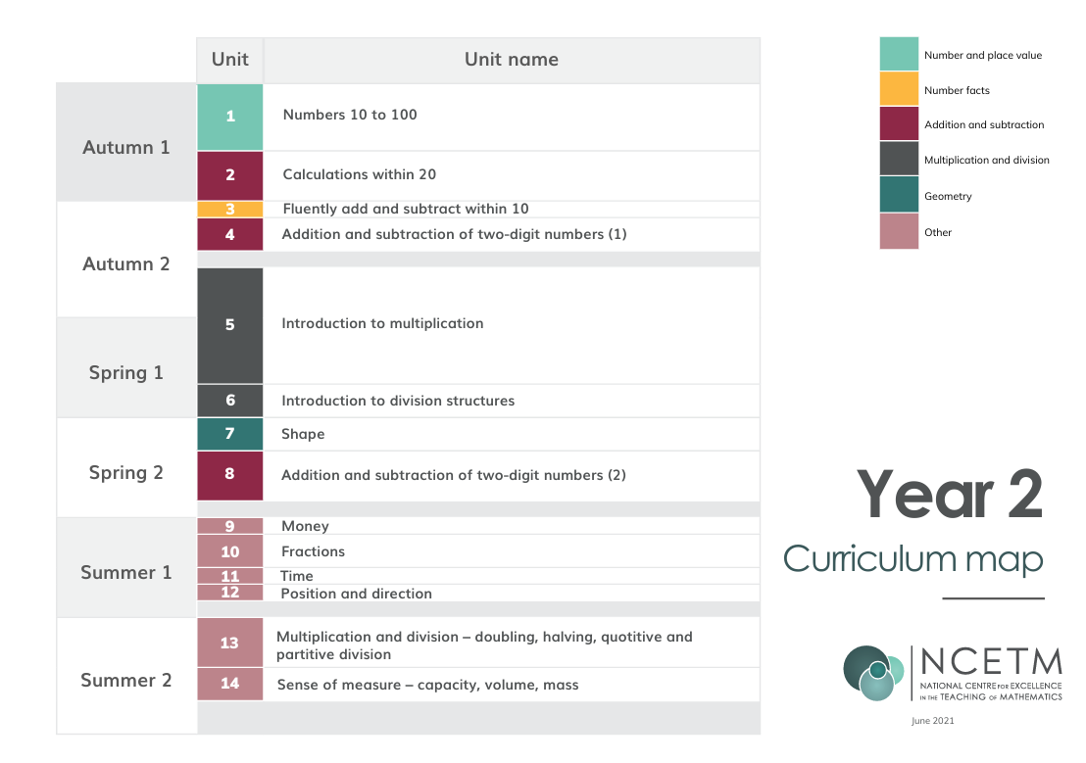
 | Autumn 1: 8 wks | Autumn 2: 7wks | Spring 1: 6wks | Spring 2: 5 wks | Summer 1: 7 wks | Summer 2: 7 wks
1 | Numbers 10-100 | Fluently add and subtract numbers within 20 | Introduction to multiplication | Shape | Fractions | Sense of measure -capacity, volume, mass
2 | Numbers 10-100 | Addition and subtraction of two digit numbers (1) | Introduction to multiplication | Addition and subtraction of two digit numbers (2) | Fractions | Sense of measure -capacity, volume, mass
3 | Numbers 10-100 | Addition and subtraction of two digit numbers (1) | Introduction to multiplication | Addition and subtraction of two digit numbers (2) | Time | Consolidation
4 | Numbers 10-100 | Introduction to multiplication | Introduction to division structures | Addition and subtraction of two digit numbers (2) | Position and direction | Consolidation
5 | Numbers 10-100 | Introduction to multiplication | Introduction to division structures | Money | Multiplication and division- doubling, halving, quotitive and partitive division | Consolidation
6 | Calculations within 20 | Introduction to multiplication | Shape |  | Multiplication and division- doubling, halving, quotitive and partitive division | Consolidation
7 | Calculations within 20 | Introduction to multilpication |  |  | Multiplication and division- doubling, halving, quotitive and partitive division | Consolidation
8 | Calculations within 20



