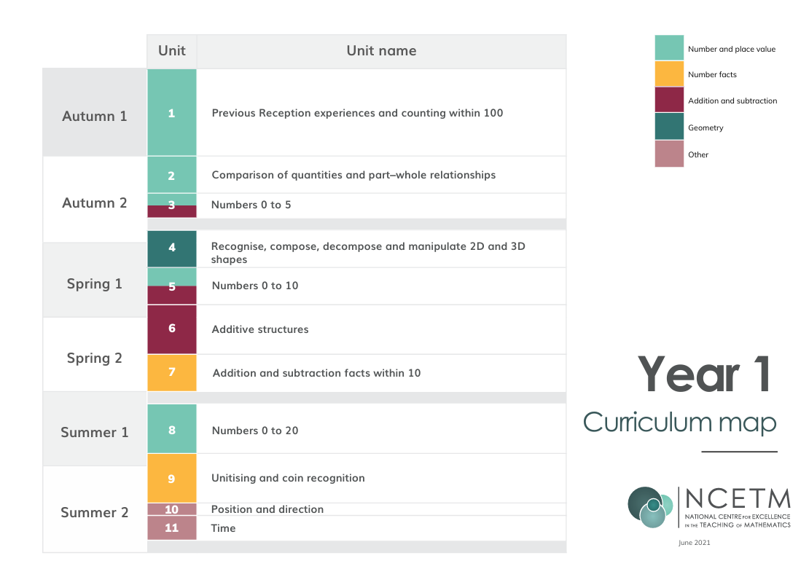

 | Autumn 1: 8 wks | Autumn 2: 7wks | Spring 1: 6wks | Spring 2: 5 wks | Summer 1: 7 wks | Summer 2: 7 wks
1 | Previous Reception experiences and counting within 100 | Comparison of quantities and part -whole relationships | Recognise, compose, decompose and manipulate 2D and 3D shapes | Additive structures | Addition and Subtraction Facts within 10 | Unitising and coin recognition
2 | Previous Reception experiences and counting within 100 | Comparison of quantities and part -whole relationships | Recognise, compose, decompose and manipulate 2D and 3D shapes | Additive structures | Numbers 0-20 | Unitising and coin recognition
3 | Previous Reception experiences and counting within 100 | Comparison of quantities and part -whole relationships | Numbers 0-10 | Additive structures | Numbers 0-20 | Unitising and coin recognition
4 | Previous Reception experiences and counting within 100 | Comparison of quantities and part -whole relationships | Numbers 0-10 | Addition and Subtraction Facts within 10 | Numbers 0-20 | Position and direction
5 | Previous Reception experiences and counting within 100 | Numbers 0-5 | Numbers 0-10 | Addition and Subtraction Facts within 10 | Numbers 0-20 | Time
6 | Previous Reception experiences and counting within 100 | Numbers 0-5 | Additive structures |  | Unitising and coin recognition | Time
7 | Previous Reception experiences and counting within 100 | Recognise, compose, decompose and manipulate 2D and 3D shapes |  |  | Unitising and coin recognition | Consolidation
8 | Previous Reception experiences and counting within 100

